TOPIC 4: CAPITAL GAINS TAX (CGT)

- Any assets prior to 20 September 1985 are not subject to CGT, that is the date CGT came in

Capital Gains Tax technically comes under statutory income.

Steps for CGT
- Is there a capital gain or loss?
- Amount of Capital gain/loss
- Calculate net capital gain/loss
- Other CGT events & records

Step 1: Is there a gain or loss?
- CGT Event (Pre requisite)
- CGT asset (Pre requisite)
- Timing of the event

Step 2: Determine amount of gain/loss
- What are capital proceeds (Div116)/modifications
- What is the cost base
- Reduced cost base
- Cost base modifications

Step 3: Calculating the gain or loss (net)
- CGT losses
- 50% general discount
- Exemptions and concessions
- Roll-over concessions
- Net capital gains as assessable income

These steps can be applied to other events:
- Event C1
- Event C2
- Event D1
- Event F1
- Event H2

Record keeping requirements for CGT

Overview
- CGT is "essentially a tax upon gains from the realisation of property where the realisation is not an aspect of the carrying on of a business".
- In other words, CGT aims to tax gains made on the disposal of assets and sometimes also to tax the receipt of certain other capital amounts that do not derive from the disposal of assets.
- Relates to assets acquired after 20 September 1985 (when CGT came into effect)

CGT Provisions
- The basic structure of s6-5 and s 8-1 is not followed by the CGT provisions.
- The CGT provisions include as assessable income a net capital gain. As such CGT is statutory income

STEP 1: Is there a capital gain/loss?
- Has a CGT event happened to the taxpayer?
- Is the asset a CGT asset?
- Does an exemption or exception apply?
- Can there be a rollover?
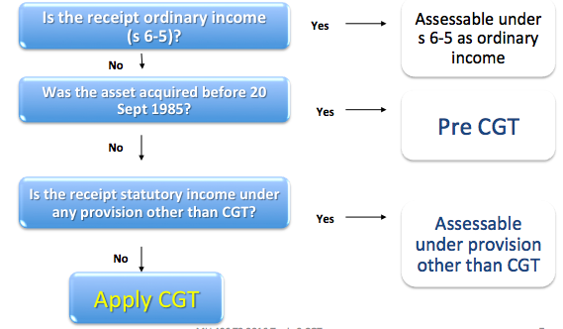

i. Has a CGT event happened?
- For Capital tax provisions to apply, s. 102-20 requires that there is a ‘CGT event’ (a summary of these events is contained in s. 104-5).
  - A taxpayer only makes a capital gain or loss if a CGT event occurs: s 102-20.
- Sometimes, more than one CGT event will happen. Generally, the most specific to the situation is used: s 102-25(1).
- Only 52 CGT events exist. For summary of CGT events, see s 104-5.
- We look at only the main CGT events
  - A1, C1, C2, D1, F1, H2
  - Event A1 is the most general: s 104-10 (Sale and disposal of assets)
- If more than one event applicable make the decision in the following order - s 102-25:
  - Ignore D1 and H2
  - Select most appropriate of remainder
  - If no other event applies try D1
  - If not D1 - try H2
  - If not H2 - no CGT
- Look at CGT Event A1 and D1 first – look at other events later

CGT Event A1 – Disposal (s 104-10(1))
- Occurs when the taxpayer disposes of a CGT asset.
- Time of the CGT event:
  - When the taxpayer enters into the contract, or
  - If no contract, when ownership change occurs. See, FCT v Sara Lee Household (2000).
- Illustration: Timing of CGT event (and hence capital gain or loss) will be in the income year ended 30 June X1
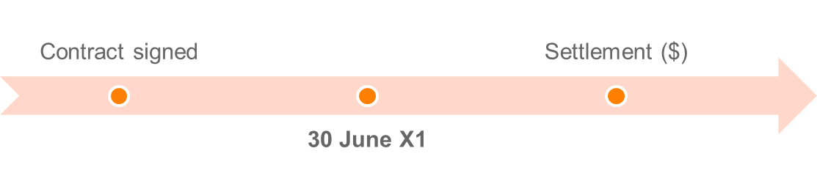

Under CGT event A1, a capital gain is made:

A capital loss is made:


- Capital Gains or losses disregarded if CGT Asset acquired before 20 September 1985 (s 104-10(5))

CGT event D1 – Creating contractual and other rights (s 104-35(1))
- Occurs where a taxpayer creates a contractual or other legal right in another entity, for example:
  - Restraint of trade where a taxpayer agrees not to operate a similar business within a particular radius.
  - Exclusive trade agreements.
- Time of the CGT event: when the taxpayer enters into the contract or creates the right.

Under CGT event D1, a capital gain is made:

A capital loss is made:


- Incidental costs include, e.g., legal costs in drawing up the contract.
- The incidental costs can also include giving property (but not a recoupment of them that is non-assessable).

- Section 104-35(5) excludes certain situations involving the creation of rights, e.g.:
  - TP creates the right by borrowing money;
  - Contractual right requires TP to do something that is a CGT Event:

S agrees to sell land to B. S creates a contractual right in the B to enforce completion of the transaction. The sale results in S disposing of the land, an example of CGT event A1. This means that CGT event D1 does not happen.

ii. CGT ‘asset’?
- You identify there is a CGT asset
- There has been disposal of the asset to trigger a CGT event
- You identify the date you had acquired the asset
- You identify the date you disposed of the asset

- Broad definition of a CGT asset. Defined in s 108-5(1) as:
  - Any kind or property; or
  - Legal or equitable right that is not property.
- Examples include:
  - Land and buildings
  - Shares in a company / units in a unit trust
  - Collectibles costing over $500 (eg, stamp collection)
  - Personal use assets costing over $10,000 (eg, boat)
  - Contractual rights (eg, restraint of trade)
  - Business goodwill.
- Commissioner has suggested bitcoin is a CGT asset. (Taxation Determination TD 2014/26)

ITAA s 108.5 - CGT assets
(1) A CGT asset is:
(a) any kind of property; or
(b) a legal or equitable right that is not property.
(2) To avoid doubt, these are CGT assets :
(a) part of, or an interest in, an asset referred to in subsection (1);
(b) goodwill or an interest in it;
(c) an interest in an asset of a partnership;
(d) an interest in a partnership that is not covered by paragraph (c).

Note 1: Examples of CGT assets are:
- land and buildings;
- shares in a company and units in a unit trust;
- options;
- debts owed to you;
- a right to enforce a contractual obligation;
- foreign currency.

‘Any kind of property’
S 108-5(a) “Any kind of property”

FCT v Orica (1998) HC
- MMBW agreed to assume Orica’s obligations under debenture trust deeds to make payments to debenture holders – Orica paid MMBW $62.3m to assume the obligations and made a profit because it “defeased” an obligation to pay $98.6m at a later time. The $62.3 million represented the aggregate of the “present values” of the debentures payable in the future.
- High Court said that Orica acquired a right to compel MMBW to perform the obligations under the debt defeasance agreement.
- Held that the right was capable of assignment and therefore was property.

Legal and equitable rights that are not property
- S 108-5(1)(b) of the definition of a CGT asset includes legal and equitable rights that are not property. This would include non-proprietary rights.
- For example, right to compensation for a cancelled contract for work.
- In Hepples v FCT (1991) 22 ATR 465 the taxpayer was paid $40,000 on his retirement for agreeing not to disclose the secrets of his employer receipt was not a substitute for income and was a capital payment for entering the restrictive covenant on termination of employment.
- A right to sue is a CGT asset
- An asset is real or intangible property
- Proprietary right – right relating to property
- Not personal rights e.g. right to work or trade
- Not civil rights - available to all

Questions:
What are the assets, if any, under s 108-5 in the following situations?
(a) The creation of a work of art - Yes
(b) Sale of a business as a going concern – Yes, goodwill, plant and equip etc., building, land and shares.
(c) The issue of new shares to a corporate shareholder - Yes
(d) A negligent act that caused a school pupil to become permanently disabled – Second limbof CGT asset, a right to sue (legal right).

Tangible
Items of tangible property (have physical existence) such as land, buildings, and chattels do not provide any difficulty when considering the meaning of the term property. They are capable of possession, ownership may be transferred and the right of ownership may be defended in a court.

Intangible
- An idea may be a CGT asset if it is manifest either in a Trademark, a copyright or an application for patent
- Something still in your head is not property (knowledge or know-how)
- If you create a patent or other industrial property over your idea or knowledge, property exists in the patent as it is transferable and may be the subject of legal action. If you sell the patent to another person, you have given up the right to use that idea and therefore you have transferred property to a new owner.

Important to classify CGT assets into their relevant categories (special rules apply to each):
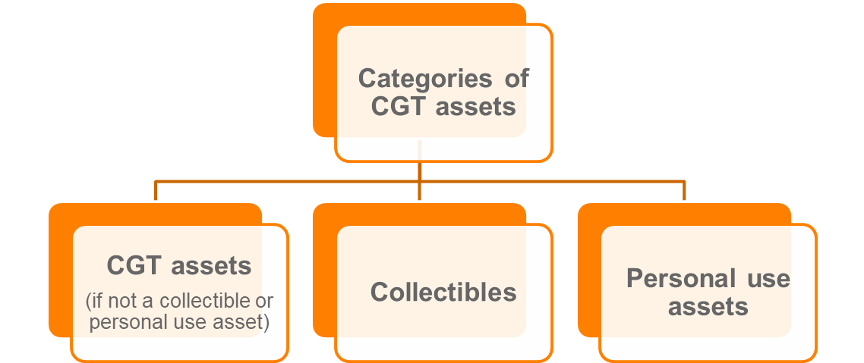

Collectables and other personal use assets
S 108.10(2) a collectable is:
- Artwork, jewellery, an antique, or a coin or medallion
- a rare folio, manuscript or book
- a postage stamp or first day cover
that is used or kept mainly for your personal use or enjoyment.

- This provision is exhaustive, if the facts indicate a different collectable, it will not fall under s 108.10(2)

Special rules apply to collectibles (s 108-10; s 118-10), as follows:
- Capital gains or losses are disregarded when the first element of a collectible’s cost base is less than $500
- Cost base of a collectible: disregard 3rd element (non-capital costs of ownership)
- Quarantining rule: capital losses from collectibles can only be used to reduce capital gains from collectibles
- Set of collectibles are treated as a single collectible

Personal use assets
Defined as an asset (other than a collectible) that is used or kept mainly for personal use or enjoyment, excluding land or buildings (s 108-20(2)).
Examples include:
  - Television at home
  - Mobile telephone for private use
  - A bicycle
  - A yacht owned for personal use and enjoyment.
- Does not include land or building, or if considered a collectible (s 108-20(3))

Special rules apply to personal use assets (s 108-20; s 118-10), as follows:
- Capital gains are disregarded when the first element of a personal use asset’s cost base is less than $10k
- Cost base of a personal use asset: disregard 3rd element (non-capital costs of ownership)
- Capital losses from personal use assets are disregarded
- Set of personal use asset are treated as a single personal use asset

- Note that collectables is exhaustive definition, so start there, then query whether personal use assets
- Should only be one sentence for assets: “the ______ is a CGT asset pursuant to s 108-5”.

Question:
Are the following CGT assets, collectables or personal use assets:
(a) An engagement ring which cost $5,000? – Personal use – used or kept for personal use (less than $10K)
(b) A second-hand car purchased for $2,000? – Gains and losses from cars are exempt: s 118-5
(c) Shares in BHP? – CGT asset
(d) Your home? – CGT asset
(e) A painting hung in the foyer of an accounting firm? – Likely a collectible if it costs <$500. Is it kept for personal enjoyment? Hard to say, if it is held by the business it will be a CGT asset.
(f) A holiday house at Byron Bay? – CGT asset

Separate CGT assets
- Common Law Rule – what is attached to land is part of the land
- Special rules that treat buildings, adjacent land and capital improvements as separate CGT assets in certain circumstances.

Pre-CGT land and post-CGT buildings (s 108-55(2))
Land acquired before 20 September 1985, a building or structure constructed on land is taken to be a separate CGT asset.

Capital improvements (s 108-70)
- A capital improvement is a separate CGT asset to the land if a balancing adjustment applies to the improvement.
- If the asset is acquired pre-CGT:
  - Cost base of the capital improvement (or related capital improvements) is > the improvement threshold; and
  - > 5% of the capital proceeds from the event.
- Improvement threshold is $147,582 (for year ended 30 June 2018) (TD 2017/16).

Other specific rules include:
- Post-CGT land is separate to the building or structure on the land if a depreciating asset or R&D balancing adjustment applies (s 108-55(1)).
- Depreciating asset that is part of a building is a separate CGT asset (s 108-60).
- Combining adjacent land onto one property title (s 108-65).

Timing – Disposal & Acquisition
- Time of acquisition of the CGT asset is generally when the taxpayer becomes its owner (s 109-5(1)).
- When acquiring a CGT asset as a result of a CGT event, specific rules in s 109-5(2) apply first, for example:
  - Where CGT event A1 occurs, the taxpayer acquires the asset when the disposal contract is entered into or if none, when the entity stops being the assets owner.
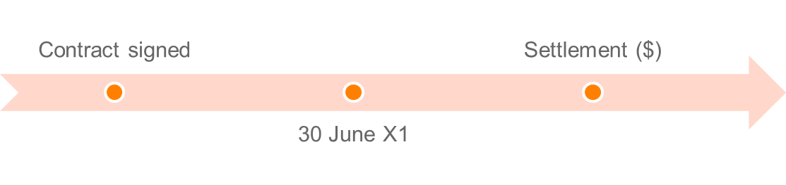
When the contract is signed is the date in which the purchaser is taken to have acquired the asset

- ^Mirror image of the timing rule for CGT Event A1 (disposals) in section 104-10

Other Specific Rules relating to when an asset is acquired:
- Section 109-5(2) specific rules for the circumstances in which, and the time at which, you acquire a CGT asset as a result of a CGT Event happening:
  - CGT Event D1 – contractual rights (CGT Asset) created when contract is entered into or right created
- CGT Asset can be acquired without a CGT Event happening (section 109-10)
  - Eg, a CGT Asset is constructed or created and Tpr owns asset when the construction or creation is finished – Tpr taken to acquire asset when construction, or work that results in the creation, started: build a building, paint a picture, write a book - the asset is acquired “when the work ... started”

iii. Exceptions and exemptions
Disregard capital gains and losses on the following assets:
- Cars, motorcycles and valour decorations (s 118-5)
- Collectibles < $500; Personal use assets
- Assets used to produce exempt income (s 118-12(1))
- Shares in a pooled development fund (s 118-13)
- Investments made in start-up companies (Subdiv 360-A)
- Depreciating assets (s 118-24(1))
- Trading stock (s 118-25)
- Otherwise assessable (anti-overlap provisions) - s 118-20 (1)
  - CGT is a last resort tax
- Personal compensation - s 118-37(1)(a) & (b)
  - Personal wrong, injury or illness
- Private lease ends - s 118-40
- Gambling and competitions with prizes - s 118-37(1)(c).

Expresses the exemptions as “disregarding the capital gain/loss”. The effect of this approach is that the asset and the event remain subject to the CGT provisions but the gain/loss is not included in the net capital gain and therefore has no effect on taxable income.
- See Div 118 may exempt
- The asset
- The receipt
- Avoid double taxation
- The transaction
- Exempt Asset
- Motor Vehicles s 118 – 5
- Collectables and Personal Use Assets s 118-10
- A collectable (acquired for < $ 500)
- A personal use asset (acquired for < $ 10,000)
- Anti-Overlap (cover these later)
- S 118-24 – depreciable assets (dealt with in Topic 4)
- S 118-25 – trading stock
- Exempt or loss denying transactions
- Personal Compensation s 118-37
- Windfall gains

Subdiv 118-B: Main Residence Exemption
- s 118-110 - Gain exempt if:
- Owned by an individual
- Dwelling is main residence
- 118-100 – full main residence
- 118-115 - caravans etc,
- 118-120 – 2HA max of adjacent land
- 118-135 - Move into in a reasonable time
- Absences s 118-145
- You may be absent from your main residence, and earn assessable income from it, for up to six years provided that you do not have another main residence.
- You can have two times six year periods. NB can only have two periods away.
- Eg Living in Melbourne, but renting out old Geelong residence = okay. However, Buying Melbourne house, but live in Geelong = not okay. Therefore, cannot claim exemption from two residents
- Build/renovate etc – 118-150/155
- Vacant land included for 4 years previous to completion and moving in.
- Accidentally destroyed – s 118-160
- Exemption continues provided no new main residence

Partial exemption
- S 118-185 Partial exemption for main residence:
- You get only a partial exemption for a CGT event that happens in relation to a dwelling or your ownership interest in it if:
- you are an individual; and
- the dwelling was your main residence for part only of your ownership period; and
- the interest did not pass to you as a beneficiary in, and you did not acquire it as a trustee of, the estate of a deceased person.
- You calculate your capital gain or capital loss using the formula:
CG or CL amount x Non-residence days/days in your ownership period
- S 118-200 Partial exemption for deceased estate
- You get only a partial exemption (or no exemption) if:
- you are an individual and your ownership interest in a dwelling passed to you as a beneficiary in a deceased estate, or you owned it as the trustee of a deceased estate; and
- section 118-195 does not apply.
- You calculate your capital gain or capital loss using the formula: CG or CL amount x Non-residence days/days in your ownership period
- Time - 118-185: Not always main residence - apportioned on days
- Partial income Use - 118-190: apportioned on deductibility of interest
- Change from main residence to income earning 118-192: market value at time first used to earn income.
- Only one main residence per family (pick one where more then one)(s 118-170)
- Your dependent child cannot have a different main residence to both parents (s 118-175)
- NB there may be partial MR exemption.. S118-185 – partial exemption when MR for only part of the ownership period. Or, S118-190: If you use part of the dwelling to produce assessable income you will pay partial CGT on your total gain

Iii Roll-over relief
Allows taxpayer to defer or disregard a capital gain or loss by way of “roll-over”. Two categories:

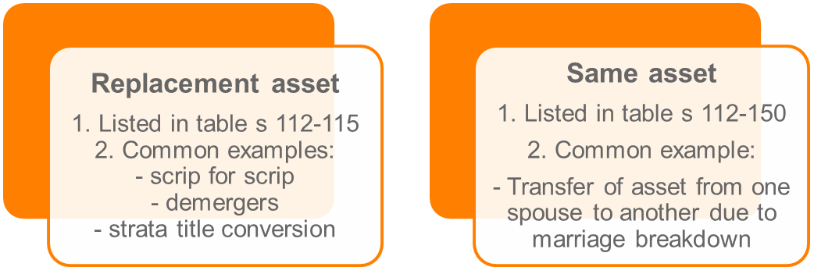

- Also when a sole trader becomes a company, sole trader owned assets transferred to company and attributable to owners share in company.
- Optional roll-over relief available from 1 July 2016 where a small business undertakes a genuine restructure but the ultimate legal ownership of the asset remains unchanged.
  - Not covered in this unit.

STEP 2: Calculating Capital Gain
- For most CGT events, a capital gain occurs when the “capital proceeds” exceeds the “cost base” of the CGT asset.

Taxpayer makes a capital gain if:


Taxpayer makes a capital loss if:


- Taxpayer makes neither a capital gain nor capital loss if the capital proceeds are less than the cost base but more than the reduced cost base.

Capital proceeds
- Capital proceeds are the amount the taxpayer receives or is entitled to receive in relation to the CGT event: s 116-20.
- Can include property (market value)
- Ignore GST on the capital proceed received: s 116-20(5).

Six modifications to capital proceeds:
- Market value substitution rule
- Apportionment rule
- Non-receipt rule
- Repaid rule
- Assumption of liability rule
- Misappropriation rule

Example
If land is sold for $200 000 and is to be paid for in four equal annual payments, then the full amount of the gain will be assessable in year one even though only one quarter of the amount has been received.

Money you receive or are entitled to receive PLUS the value of property you receive or are entitled to receive… i.e. if you sell your house for $300,000 plus acquire an apartment worth $200,000 = $500,000.

- “Market value” modification - S 116-30
- Applies when the taxpayer:
  - Receives no capital proceeds;
  - Some or all capital proceeds cannot be valued; or
  - Did not deal at ‘arm’s length’ with the other entity.
- Capital proceeds are deemed to be the market value ‘Arms-length’: an unrealistic value for purchase normally because of the relationship (e.g. Candice sold me her house for $10 because we’re friends).
  - Would the reasonable person consider the sale at arm’s length?

- Apportionment modification - S 116-40
- When a single proceed is the total of two or more events, the proceeds must be apportioned between those events.
- E.g. A lump sum of $800,000 for the sale of house and a yacht, these will need to be apportioned to determine the value of each
- Illustration: capital proceeds are for land and buildings; but need to be apportioned to the building (land is pre-CGT).
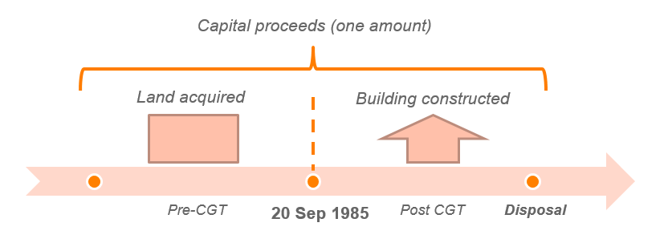
See TR 118/5^

- Non-receipt rule - S 116-45
Allows the Capital Proceeds to be reduced by any amount that you have not received and will not receive after all reasonable attempts have been made to get it.

- Repaid Rule - S 116-50
- Capital proceeds are reduced to the extent the taxpayer has to repay capital proceeds already received.
- Reduces the capital proceeds by any non-deductible amount paid as compensation resulting from the CGT Event (i.e. if sued after settlement of house for $300,000 and you need to pay $40,000 compensation, it will be reduced to $260,000 due to the compensation payment)

- Assumption of liability rule - S 116-55
- Capital proceeds are increased if another entity assumes liability in connection with the CGT event. (I.e. pay you $100k plus take over mortgage for $100k).
- E.g. John sells apartment for $250,000 and purchaser took over $50,000 debt = capital proceeds will be $300,000

- Misappropriation Rule - S 116-60
- Allows you to reduce capital proceeds by any amount misappropriated by an employee or agent.
- E.g. Real estate agent takes the 10% deposit from a house sale, this 10% will be deducted

Cost base
- Cost base are the total costs associated with the CGT asset.
- The cost base is reduced to the extent GST input tax credits have been claimed by the taxpayer.

S 110-25 Cost Base
- The general definition of cost base in s.110-25 defines cost base as consisting of five elements:

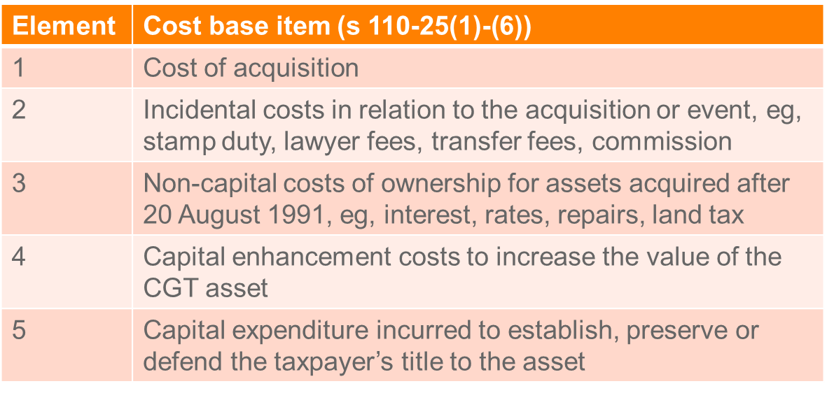

Element 1: Money or value of property given for acquisition - S 110-25(2)
Modifications that reduce in CP in s 116-25 will fall under this element (e.g. borrowing expenses deducted cannot be double dipped in the CB)

Element 2: Incidental costs related to acquisition and CGT event (disposal) - S 110-25(3)
Incidental costs list at s 110-35: incidental costs defined. It must be included in one of the nine categories otherwise not allowed
- Remuneration for legal advisor, accountant, valuer, auctioneer (2)
- Cost of transfer (3)
- Stamp duties (4)
- Marketing and advertising (5)
- Valuations (6)
- Search fees (7)
- Conveyancing kit (8)
- Borrowing expenses (9)
- Corporate groups (10)

Deductible amounts not included

Element 3: Costs of ownership (assets purchased after 20 Aug 1991) - S 110-25(4)
- Includes: interest, maintenance, rates and insurance.
  - Deductible amounts not included
- Not allowed for collectibles and PUAs

Element 4: Capital expenses relating to the asset - S 110-25(5)
- Expense to increase or preserve asset’s value
- Expense to install or move the asset
- Does not include costs related to goodwill
  - E.g. expenses for renovating a house would fall under this element

Element 5: Capital expenses relating to title - S 110-25(6)
- Preserving the assets title
- May arise where you litigate to reinforce our title. Eg litigation regarding adverse possession and the costs of litigating to preserve your title

Other factors affecting cost base
- Sec 110-38: excludes penalties, bribes, entertainment, illegal activities
- Sec 110-45: CGT assets acquired after 13/5/97, all deductible amounts not included
- Sec 103-30: CGT events after 19/2/2004 GST input credits not included in cost base

- Generally a capital gain is the difference between the cost base of an asset and the capital proceeds from a GCT event in relation to that asset.
- The concept of cost base is crucial in the calculation of the capital gain or loss for most CGT events.
- For assets acquired after 7.30 pm on 13 May 1997 s. 110-45 makes it clear that an expense that is deductible under another provision of the Act cannot be included in any of the cost base elements.

S 110-25 - General rules about cost base
(1) The cost base of a CGT asset consists of 5 elements.
Note 1: You need to keep records of each element: see Division 121.
Note 2: The cost base is reduced by net input tax credits: see section 103-30.
Note 3: An amount that makes up all or part of an element of the cost base of an asset may be determined under section 230-505, if the amount is provided for acquiring a thing, and you start or cease to have a Division 230 financial arrangement as consideration for the acquisition of the thing.
5 elements of the cost base
(2) The first element is the total of:
(a) the money you paid, or are required to pay, in respect of acquiring it; and
(b) the market value of any other property you gave, or are required to give, in respect of acquiring it (worked out as at the time of the acquisition).
Note 1: There are special rules for working out when you are required to pay money or give other property: see section 103-15.
Note 2: This element is replaced with another amount in many situations: see Division 112.
(3) The second element is the incidental costs you incurred. These costs can include giving property: see section 103-5.
Note: There is one situation to do with options in which the incidental costs relating to the CGT event are modified: see section 112- 85.
(4) The third element is the costs of owning the CGT asset you incurred (but only if you acquired the asset after 20 August 1991). These costs include:
(a) interest on money you borrowed to acquire the asset; and
(b) costs of maintaining, repairing or insuring it; and
(c) rates or land tax, if the asset is land; and
(d) interest on money you borrowed to refinance the money you borrowed to acquire the asset; and
(e) interest on money you borrowed to finance the capital expenditure you incurred to increase the asset's value.
These costs can include giving property: see section 103-5.
Note: This element does not apply to personal use assets or collectables: see sections 108-17 and 108-30.
(5) The fourth element is capital expenditure you incurred:
(a) the purpose or the expected effect of which is to increase or preserve the asset's value; or
(b) that relates to installing or moving the asset.
The expenditure can include giving property: see section 103-5.
Note: There are 3 situations involving leases in which this element is modified: see section 112-80.
(5A) Subsection (5) does not apply to capital expenditure incurred in relation to goodwill.
(6) The fifth element is capital expenditure that you incurred to establish, preserve or defend your title to the asset, or a right over the asset. (The expenditure can include giving property: see section 103-5.)

Cost Base Modifications
- Just like there are modifications to capital proceeds, there are modifications to the cost base. Modifications can occur from the time you acquire the asset to when the CGT event happens in relation to it. Most modifications replace the first element (what you paid for the CGT asset) of the cost base and reduced cost base of the asset.
- The most important of the Div. 112 modifications are:
- Replacement of actual cost with market value where consideration is nil, cannot be determined or is not at arm’s length s.112-20;
- Apportioning costs between assets that are split into more than one asset of changed into different nature and adding together costs of merged assets s.112-25;
- Apportioning costs when only part of an expense relation to an asset of CGT event; s 112-30
- Including any assumed liability by taxpayer when asset was acquired – i.e. taking over a debt s 112-35

‘Arm’s length’
- One of the most important aspect to appreciate here is that s 112-20 (2) is not a test of whether the two parties are at arm’s length or not (e.g. a husband and wife), but it is a test of whether the parties are dealing at arm’s length (Elmslie & Ors v. FCT (1993) 26 ATR 611; 93 ATC 4964).
- The test of an arm’s length transaction is whether the price agreed is similar to an open market price. In Granby Pty Ltd v. FCT (1995) 30 ATR 400; 95 ATC 4240 Lee J stated, ‘What is asked is whether the parties behaved in the manner in which parties at arm’s length would be expected to behave in conducting their affairs.’ Dealing at arm’s length can therefore be equated to a test of market value.

S 112-20 - Market value substitution rule
(1) The first element of your cost base and reduced cost base of a CGT asset you acquire from another entity is its market value (at the time of acquisition) if:
(a) you did not incur expenditure to acquire it, except where your acquisition of the asset resulted from:
(i) CGT event D1 happening; or
(ii) another entity doing something that did not constitute a CGT event happening; or
(b) some or all of the expenditure you incurred to acquire it cannot be valued; or
(c) you did not deal at arm's length with the other entity in connection with the acquisition.
The expenditure can include giving property: see section 103-5.
(2) Despite paragraph (1)(c), if:
(a) you did not deal at arm's length with the other entity; and
(b) your acquisition of the CGT asset resulted from another entity doing something that did not constitute a CGT event happening;
the market value is substituted only if what you paid to acquire the CGT asset was more than its market value (at the time of acquisition).

‘Reduced cost base’ for capital losses (s 110-55)
- Reduced cost base is used for the purpose of working out a capital loss.
- Largely the same as cost base, except for two notable differences:
  - 3rd element is any amount that is included in the taxpayer’s assessable income because of balancing adjustments. All other elements are the same.
  - Reduced cost base cannot be indexed.
- Capital losses are determined by comparing the capital proceeds with the reduced cost base. In essence, the definition of reduced cost base in s. 110-55 is similar to the definition of cost base, but with the following important differences:
- reduced cost base is not indexed (s. 110-55(1))
- Element 3 of the reduced cost base does not include costs of ownership and is very limited.
- Therefore, it is reduced by not allowing element 3 to be considered
- Therefore, remove element 3 where you thinkt the answer was gain and it was actually a loss
- Unlikely that this will be examinable either^

Indexation (not examinable)
- NOTE: Need to know that it exists. Prior to 21 September 1999 the cost base could be indexed to reflect current inflation, thus reducing the overall gain.
- Indexation of the cost base was introduced so that capital gains tax would not be a tax on inflation (Div 114). However, indexation is only applicable for the determination of capital gains and not capital losses (s. 114-1), and indexation is also not available if the asset was acquired after 11.45 am 21 September 1999.
- For an asset purchased before 21 September 1999 that is sold after that date the taxpayer has a choice of applying indexation or the general discount of 50% (see later in this topic). This is as much as you need to know about indexation.

STEP 3: Calculate Net capital gain/loss for FY

Five-step process to calculate the net capital gain (ie gains and losses for all events in the income year)
- Current year capital gains less current year capital losses (in the order the taxpayer chooses - Note special rule re collectibles)
- Remaining capital gains are reduced by any unapplied net capital losses from previous years (in the order the taxpayer chooses, however applied in the order they were made) (Note collectibles)
- Reducing any remaining discount capital gains by the discount percentage (50%)
- Any remaining capital gains: Apply small business concessions (if available)
- Any remaining capital gains - Add up: any remaining capital gains that are not discount capital gains + any remaining discount capital gains

Sec 102-5: Assessable amount is NET capital gain
- Determine the gain/loss for separate events (Eg CGT for house and then the CGT for boat in separate calculations). Apply exclusions and rollover.
- There are no exempt CGT assets
- Gains/losses may be disregarded in part or in full
- Rollover is a deferral so gain/loss will effect a later tax return.
- May rollover excess CL

Capital losses
- A capital loss cannot be deducted from the taxpayer’s assessable income: s 102-10(2).
  - Capital losses are carried forward to a later income year
(s 102-15(1)).
- Capital losses only used against capital gains – special rules for collectibles and personal use assets.
  - Net losses for the year can be carried forward indefinitely
- All losses must be applied before general discount and other concessions (Eg. CG for house and CL for boat, Apply the loss from boat before applying the 50% general discount. If formula is done after could result in a different value)
  - Capital gain/loss adjusted for exclusions, concessions and rollovers.

Discount method (step 3 of working out a net capital gain)
Eligibility (see Div 115):
- CGT asset must have been held for more than 12 months.
- CGT event must have occurred after 11.45 am on 21 September 1999.
  - Not examined on indexation so a CGT event will occur post 21/9/99 for exam purposes
- Certain CGT events are ineligible (exempt), eg, D category events.
  - Sec 115-25(3): Only applies to certain events – Not: D1, D2, D3, E9, F1, F2, F5, H2, J2, J5, J6, or K10

Discount percentage:
- 50% for individuals (Only discount we need to know for exam purposes)
- 33.3% for superannuation funds
- 0% for companies

Revision questions
Discussion Question 1
Brendan Brown is a recently retired AFL footballer that has lived in Melbourne throughout his life. In November 2013, Brendan accepted a position as an assistant coach of the new AFL team located in Sydney, the Owls.

Before Brendan and his family relocated to Sydney he disposed of the following assets:

Asset | Purchase Date | Purchase Price | Sale Date | Sale Price
Investment Property | 15 Sep 1998 | $200,000  (Note 1) | 31 Jan 2014  (Note 2) | $900,000  (Note 3)
Sail Boat | 10 Jul 2013 | $60,000 | 1 Feb 2014  (Note 4) | $81,000
Caravan | 18 Nov 2009 | $15,000 | 10 April 2014 | $11,000
Ford Motor Car | 15 Feb 2006 | $28,000 | 14 May 2014 | $16,000
Postage Stamps Collection | 14 Dec 1994 | $14,500 | 31 Mar 2014 | $28,000

Notes

- Stamp duty and legal costs totaling $20,000 was paid by Brendan on 15 Dec 1998.

- The Contract of Sale was signed 31 Jan 2014 with possession to pass to the purchaser at settlement on 31 July 2014.

- A deposit of $90,000 was received on 31 Jan 2014. The balance of $810,000 is due at settlement on 31 July 2014. At settlement Brendan will be required to pay the estate agent’s commission of $40,000 and legal expenses of $5,000.

- The sale of the sailboat was arranged through a selling agent who charged $1,000 commission.

Brendan had a loss from the sale of a sculpture in the amount of $5,000 from the 2009/10 income year.

Required: Advise Brendan of his net capital gain for the year ending 30 June 2014. Please show all calculations and cite relevant legislation to support your answer.
Ford motor car: CGT event A1 has happened to the car, but it is a personal use asset: s 118-5 exempts capital gains or losses that happen to cars (not a CGT asset).

Caravan: CGT event A1 has occurred. Personal use asset. Capital loss made from a personal use assets are disregarded s 118-10; s 108-20

Sail boat: CGT event A1 has happened to the sail boat. We are not told that there is a separate contract, so CGT event date is presumed to be when the change of ownership occurred: 1 Feb 14. Personal use asset – capital gain. Special rules of less than $10K do not apply here. CB = $60K + $1,000 (incidental cost). $81K - $61K = $20k CG. No discount as less than 12 months.

Postage stamps: CGT event A1 has occurred as there has been a disposal. Collectible - Not less than $500, so the quarantining rules are disregarded. S 104-10 applies so CG has to apply. What’s received is $28K (s 116-20), CB = $14,500 (s 110-25). CG = $13,500. Prior year loss: Sale of sculpture cannot be applied against any other assets, other than collectibles (the postage stamps): s __ Postage stamp CG with loss offset ($13,500 - $5,000) = $8,500, discount CG = $4,250.

Investment property: A1 CGT event has occurred. CB = E1 $200K + E2 $20K (costs of acq) + $45K (costs of sale), CG = $900K - $265K = $635K. Discounted CG = $317.5K. Taxable in 14 FY as it is the date in which the contract is signed in which the asset is taxed accordingly (2014 FY).

Total CG = $20k + $4,250 + $317.5 = $341,750

Note^ check section accuracy before exam

Discussion Question 2
George is a manager at Wollongong Steel Ltd. His employment contract is for 10 years. In the third year George‘s position at the company is made redundant, and his employment terminated. George enters into a restrictive covenant with Wollongong Steel Ltd which provides that:
- in return for a payment of $40,000 he agrees not to disclose any trade secrets of his employer to any other person; and
- in return for a payment of $200,000 he agrees that he will not work for a competitor for a period of 18 months after his employment with the company ends.

CGT event – D1 has happened. Created rights with Wollongong steel via contract in return for a contract: s 104-35. Time of the event is when the rights were created (signing the contract). Capital proceeds - $240K, no CB, so CG is $240K. Cannot apply CG discount, CGT discount does not apply as it has not been held for a period of time, it happens all instantly. The whole amount will go into assessable income under s 102-5 ITAA 97.

Change the facts: $240K is a sign on fee. The amount would then be OI. Whether it is a CG or OI does not apply as the end result is the same but s 102-5 but makes it OI.

Discussion Question 3
Colette is a Chartered Accountant with her own business. Due to the retirement of a number of her clients, the business was starting to make a loss for the first time in twenty years. To cover the loss, she decided to start disposing of her assets. Her portfolio is as follows:

Item | Purchase Date | Purchase Price | Sale  Date | Sale  Price
Property in Thornbury | 1 May 1985 | $20,000 | 30 June 2017 | $700,000
Subaru Outback Wagon (Vehicle) | 1 Oct 2012 | $40,000 | 1 May 2017 | $15,000
Sculpture | 18 Sep 1985 | $11,000 | 1 May 2017 | $55,000

Colette sold her Thornbury property to her brother, and the transaction settled on 1 July 2017. At the time, the market value of the property was $900,000.

When she bought the property on 1 May 1985, it was a vacant block of land. A broker sourced the land for her after undertaking preliminary investigations of the surrounding areas. The broker’s fee was $900. On finding the property, the acquisition costs included legal fees of $990 and stamp duty of $10,000.

On 1 July 2013, Colette built a house on the property at a cost of $200,000 (land was valued at $400,000). The house has been rented out since completion and Colette pays bank interest of $25,000 per annum.

On 22 September 2016, Colette inspected the Thornbury property and decided to renovate it, undertaking the following:

- Replacement of the kitchen at a cost of $50,000;
- Replastering and repainting a wall which had been damaged due to a leak costing $20,000;

Colette also has a carry forward capital loss from the sale of shares from the 2010-2011 income year in the amount of $6,000.

Sculpture: CGT event A1 has happened to the collectible. Purchase date indicates this asset is a pre-CGT asset, thus exempt from capital gains tax.

Car: CGT event A1 has occurred. It is a personal use asset. However CGs or CLs on motor vehicles are exempt under s 118-5.

Property: CGT event A1. The cost of building the house on its face is deductible under s 8-1 as it has been built for an income purpose. But the expense is capital in nature, so no deduction under 8-1. The interest is deductible under s __. Replacing the kitchen is arguably changing the income producing activity, but it is a capital expenditure so no deduction under 8-1. Re-plastering and re-painting the wall is a repair under s 25-10 and is deductible under 8-1. Div 43 capital write off will be allowed here for all the construction costs and improvements:
- Construction costs (200K) x 2.5% = $5,000 (note held for full FY), X 4 years = $20,000 worth of deductions
- Kitchen replacements = $50,000x 2.5% x 282/365= $966 deduction for 17FY
Total Div 43 deductions = $20,966.

Contract date = 30 June 17, so gain has to be reported in 17FY. The land however is a pre-CGT asset. But the house is a post-CGT asset: s 108-55. So the house is a separate asset from the land for CGT purposes. Calculate the CG only on the house. But the capital proceeds relate to both the house and the land, so an apportionment is needed s 116-40 (modification 4). Here the capital proceeds are $700K, but the circumstances in which the sale occurred was not at arm’s length, so the market value substitution applies ($900K) – s 116-30 (modification). The land was valued at $400K and $200K and the time of their respective purchases (expenses), indicating that the building is going to be 2/3’s of the capital proceeds. ($300K).

CB
- E1 costs: $200K.
- No E2 costs as the only possible expenses relate to the land purchase.
- S 118-25: expenses relating to the house should not go into the cost base as they were deducted throughout the year – no double dipping.
- E3: Kitchen expenses less all capital write offs applied ($50K - $916 - $20K = $229,034)

Capital proceeds = $300K – 229,034 = 70,966.
Less capital loss carried forward = 70,966 – 6000 = 64,966, X 50% = discounted CG of $32,483.

Discount if held for more than 12 months: s 115-25

Note^ check section accuracy before exam
Won’t get a question quite like this on the exam.

4. Other CGT Events
- CGT event A1 is the most general event but the following are also important.
- The events are outlined in s 104-5 (this is a good overview).
- S 104-5 Events (only ones covered in unit):
- A1 – disposal of a CGT asset
- C1 – loss or destruction of a CGT asset
- C2 – cancellation, surrender and similar endings
- D1 – creating contractual or other rights
- F1 – granting a lease
- H2 – receipt for event relating to CGT asset

Steps for Answering CGT question:
- Is there an event? Which event is it?
- Go to the relevant provisions for that event to see what you are required to do to calculate the Capital Gain or Loss and obtain formula (i.e CGT event A1 s104-10(4) … CG = CP – CB)
- Work out the CP (under Div 116)(remember modifications)
- Work out the CB (Under s110-25)(remember modifications)
- Now go back to the original formula to work out the CG.
- Consider general discount, exemptions or concessions
- Section 102-20 state that a capital gain/loss only occurs if a CGT event happens and s. 104-5 sets out the events that need to be considered.
- Therefore, you need an event to occur to have CGT consequences. You need to determine which event applies as this may affect how you work out capital gain or loss (and may determine the timing of it).

CGT Events
- A taxpayer only makes a capital gain or loss if a CGT event occurs: s 102-20.
- Sometimes, more than one CGT event will happen. Generally, the most specific to the situation is used: s 102-25(1).
- 52 CGT events exist. For summary of CGT events, see s 104-5.
- We have already looked at CGT Event A1 and D1
- We look at only the main CGT events:
  - A1 – disposal of a CGT asset
  - C1 – loss or destruction of a CGT asset
  - C2 – cancellation, surrender and similar endings
  - D1 – creating contractual or other rights
  - F1 – granting a lease
  - H2 – receipt for event relating to CGT asset

S 104-10(1): Review of CGT Event A1 – Disposal of a CGT Asset
- Event A1 is the most significant - Change in ownership of CGT asset s104-10(1)
- The A1 Elements
- CGT Asset
- Disposal
- Time
- Capital Gain or Capital Loss
- Exceptions
- 104-10(3) [Time of the event]
- The time of the event is:
- when you enter into the contract for the *disposal; or
- if there is no contract - when the change of ownership occurs.
- 104-10(4) [Capital gain and capital loss]
- You make a capital gain if the *capital proceeds from the disposal are more than the asset's *cost base. You make a capital loss if those *capital proceeds are less than the asset's *reduced cost base.
- 104-10(5) [Capital gain or loss disregarded]
- A *capital gain or *capital loss you make is disregarded if:
- you *acquired the asset before 20 September 1985; or
- for a lease that you granted:
- it was granted before that day; or
- if it has been renewed or extended - the start of the last renewal or extension occurred before that day.

S 104-35: D1 CGT Event – Creation of Contractual Rights
- D1 - Creation of contractual rights
- Event D1 applies where a person enters into a contractual agreement with another entity which acquired the rights under that agreement.
- There is no need to have a CGT asset.
- Event D1 deems a capital gain to arise where payment is received for the creation of a contractual right.
- The time of the event, is when you enter into the contract or create the other right s104-35(2).
- Discount NOT available
- Hepples: contract with former employer to not tell others of employer’s trade secrets
- s 104-35 : creation of a contractual right
- last resort - except H2
- Gain or loss – only incidental costs allowed
- Originally there were specific provisions in ITAA 1936 in relation to taxing capital amounts received when contractual rights were created. These were found to be ineffective in Hepples v FCT:
- In this case, the taxpayer received an amount of $40,000 in return for an agreement that he entered into. The agreement was a restrictive covenant, which followed termination of his employment. The Commissioner included this amount as income on the basis that it constituted a Capital Gain under Pt IIIA. (Remember Net Capital Gains are to be included in assessable income)
- Court said NO. Court said that s 160A was confined to proprietary assets that were recognised by law. The taxpayers right to wok and the choses in action that arose out of the restrictive covenant were not proprietary in nature and so could not fall under the s160A asset definition.
- Note that the Law changed in June 1992. The new second limb of the definition of a CGT asset now includes legal and equitable rights that are not property. S 108-5(1)(b).
- The ITAA36 provisions amended in 1992 but there were still issues with the provisions which were ‘deeming provisions’ to deem the entry into a liability to be creation and disposal of capital asset. CGT Event D1 seems to overcome these difficulties.

Example:

You enter into a contract with the purchaser of your business not to operate a similar business within the same town. The contract states that $20,000 was paid for this. You have created a contractual right in favour of the purchaser. The time of the event was when contract entered into. If you paid your lawyer $1500 to draw contract then your capital gain would be $18,500.

- Note that D1 does not happen where the right requires you to do something that is another CGT event.
- For example: You agree to sell land. You have created a contractual right in the buyer to enforce completion of the transcation. The sale results in you disposing of the land (say CGT event A1) this means that gain or loss from D1 does not happen.

S 104-20: CGT Event C1 – Loss or Destruction of a CGT Asset
- Applies to tangible assets
- Occurs if a CGT asset that the taxpayer owns is lost or destroyed.
- Time of the CGT event: when the taxpayer first receives compensation for the loss or destruction, or if no compensation, when the loss is discovered or the destruction occurred: s 104-20(2)
- To the extent that the capital proceeds exceed the cost base of the asset, a capital gain will result; to the extent that the reduced cost base of the asset exceeds the capital proceeds, a capital loss will arise (subsection 104-20(3) of the ITAA 1997).

Example 1:
House with a cost base of $200,000 burn down. Insurance pays the taxpayer $250,000
- Capital Proceeds $ 250,000
- Cost Base: $ 200,000
- Capital Gain $ 50,000 (disregarding indexation and 50% discounting)

Example 2:
House with a cost base of $ 200,000 burns down. No insurance.
- Capital Proceeds $ 0
- Reduced cost base $ 200,000
- Capital loss $ 200,000

- If this is the example applied in the exam and there is no compensation, you can note that a rollover of CL may apply

Example 3:
On 12 November of the current tax year your client had an antique four-poster Louis XIV bed stolen from her house. She recently had the bed valued for insurance purposes and the market value at 31 October of the current tax year was $25,000. She purchased the bed for $3,500 on 21 July 1986. Although the furniture was in very good condition, the bed needed alterations to allow for the installation of an innerspring mattress. These alterations significantly increased the value of the bed, and cost $1,500. She paid for the alterations on 29 October 1986. On 13 November of the current tax year she lodged a claim with her insurance company seeking to recover her loss. On 16 January of the current tax year her insurance company advised her that the antique bed had not been a specified item on her insurance policy. Therefore, the maximum amount she would be paid under her household contents policy was $11,000. This amount was paid to her on 21 January of the current tax year.

- CGT Event C1 occurs when the antique bed was stolen.
- The timing of the event is when the insurance proceeds were received on 21 January: s 104-20.
- The antique bed is a collectable: s 108-10
- Any gains or losses are not disregarded as acquisition cost > $500: s 118-110(1).
- The cost base of the bed = $3,500 + $1,500 = $5,000
- Alterations are included in element 4 of cost base: s 110-25(5).
- A capital gain exists as sale proceeds > cost base
  - Gain = $11,000 – 5,000 = $6,000
  - Gain is an eligible discount capital gain: Subdiv 115A

S 104-25: CGT Event C2 – Cancellation, Surrender or Similar Endings
- Applies to intangible assets
- Occurs if, broadly, ownership of the taxpayer’s intangible asset ends by, among other things, cancellation or expiration.
- Time of the CGT event: when the taxpayer enters into the contract that results in the asset ending, or if there is no contract, when the asset ends: s 104-25(2)
- To the extent that the capital proceeds exceed the cost base of the asset, a capital gain will result; to the extent that the reduced cost base of the asset exceeds the capital proceeds, a capital loss will arise (subsection 104-25(3) of the ITAA 1997).
- Event C2 occurs where ownership of an intangible CGT asset ends as a result of the asset:
- Being redeemed or cancelled (eg shares/ debentures)
- Being released, discharged or satisfied (a debt)
- Expiring (contractual rights)
- Being abandoned, surrendered or forfeited (contractual rights)

Example:
Where an intangible asset ends:
- Arthur has an agreement with the McDonalds Company to run a McDonalds outlet. It has cost Arthur $100,000 to enter into an agreement when he first entered into it.
- At the end of 5 years, there had been an event C2 – being the right to run the McDonalds outlet ending.
- Reduced Cost base = $100,000 (this is the amount that it cost Arthur to enter into the agreement)
- Capital Proceeds = $0 (because Arthur has not received any money upon the agreement ending)
- Therefore Capital Loss is $100,000

Example 2:
- Deakin pays Monica $50,000 to not work anywhere else for three years
- Deakin now have a contractual right for three years
At the expiration of these three years, there will be a CL of $50,000.

FCT v Orica (1998) 39 ATR 66
- In the FCT v Orica case, the taxpayer entered into a debt defeasance agreement with MMBW whereby in return for agreeing to pay MMBW $62.3M, MMBW would meet the taxpayers liability to pay the principle on debentures it had issued with a face value of $98.6M.
- High Court commented that the taxpayers business was one of a chemical company and that the debt defeasance transactions were outside the scope of the business, and so the Myer Emporium doctrine did not apply to make any gains assessable income under s 25(1) (now s6-5). Nor could they constitute statutory under s 25A (profit making undertaking or scheme). Crt commented that the discharge of a future liability by a lesser amount immediately did not constitute a profit. It was merely an accounting difference.
- However they held that the arrangements did fall under the CGT regime.
- Held: that each time MMBW effected a payment there was a deemed disposal of part of the taxpayers asset under s 160 (3)(b) (predecessor of s 104-25, Event C2). Under the debt defeasance agreement the taxpayer acquired rights against MMBW and these rights constituted an asset under s 160A.

Example 3:
Beta enters into a restrictive covenant with Delta. Delta pays Beta $50,000 for entering into the restrictive covenant. The term of the restrictive covenant is 5 years. Delta’s rights under the restrictive covenant will be a CGT asset to Delta.
When the restrictive covenant expires, CGT event C2 will happen. There will be no capital proceeds and MVS will not apply (because expiry of CGT asset owned and C2 event see s 116-30(3)). Capital proceeds therefore zero.

There would be capital loss of $50,000

Example 4:
B Co is a company listed on the ASX. On 12 December 2016, B Co undertook a Selective Capital Reduction by way of a share cancellation. The proposal was to cancel all shares in B Co not held by its holding company, effectively privatising the company. B Co announced it would outlay approximately $45 million to implement the proposed capital reduction of approximately 15 million shares.

CGT Event C2 happens to the shares on the date the shares are cancelled.
To the extent that the capital proceeds exceed the cost base of the B Co shares, a capital gain will result; to the extent that the reduced cost base of the B Co shares exceeds the capital proceeds, a capital loss will arise (subsection 104-25(3) of the ITAA 1997).

S 104-110: CGT Event F1 – Lease Grant or Renewal
- CGT event F1 (s. 104-110) occurs when a lease is granted, renewed or extended.
- Event F1 is aimed at taxing lease premiums (lump sum payments to the lessor).

The time of the event is:
(a) for the grant of a lease:
(i) when the contract for the lease is entered into; or
(ii) if there is no contract--at the start of the lease; or
(b) for a renewal or extension--at the start of the renewal or extension.

- The lessor makes a capital gain if the capital proceeds from the grant, renewal or extension are more than the expenditure it incurred on the grant, renewal or extension. It makes a capital loss if those capital proceeds are less.
- Discount NOT available in this event

Example:
CGT event F1 will occur if a lessor enters into a three year lease, and the lessee agrees to pay an upfront premium of $20 000 as well as rent of $1000 per month. In this case, the $20 000 premium will be subject to event F1, and the $1000 rent per month will constitute ordinary income.

Example: Receiving an amount for granting a lease
Elisabeth operated a footwear retailing business and wished to lease some shop space in a prestigious location in the Sydney CBD. There was considerable demand for shop space in the locality and competition between prospective tenants was fierce. To secure the lease of the particular shop space she wanted, Elisabeth paid Jean Paul (the owner of the shop space) a premium of $6,000 for the grant of that particular lease.

She entered into the lease on 6 September 2016, and Jean Paul incurred stamp duty of $300 and solicitor's fees of $500 on the grant of the lease.

Jean Paul made a capital gain of $5,200 from CGT event F1:
- Capital proceeds: $6,000
- Incidental costs (stamp duty and solicitor's fees): $800
For Elisabeth, this transaction results in CGT event C2 (cancellation, surrender and similar endings) when the lease expires.
- Capital Proceeds: $0
- Cost Base: $6,000
- Capital Loss: $6,000

S 104-155: CGT Event H2
- Very last resort – consider all other events first
- Amount received from an act or transaction in relation to an asset
- The time of the event is when the act, transaction or event occurs.
- Limited application

Example: Max owns land on which he intends to construct a manufacturing facility. A business promotion organisation pays Max $50,000 as an inducement to start construction early. No contractual rights or obligations are created by the arrangement.

The payment is made because of an event (the inducement to start construction early) in relation to Max’s land so CGT Event H2 happens.

To the extent that the capital proceeds exceed the incidental costs relating to the event, a capital gain will result; to the extent that the incidental costs exceed the capital proceeds, a capital loss will arise (subsection 104-155(3) of the ITAA 1997).

3. Exceptions and exemptions

Main residence exemption
Basic exemption allows a capital gain or loss arising from a CGT event where the CGT asset is a dwelling and the:
- Taxpayer is an individual; and
- The dwelling was the taxpayer’s main residence throughout the whole of ownership period: s 118-110 (1).

Acquire new home before selling old home?
Time to move between dwellings: s 118-135.
Changing residences (s 118-40):
- If you acquire a new home before you dispose of your old one, both dwellings are treated as your main residence for up to six months if:
  - you lived in your old home and it was your main residence for a continuous period of at least three months in the 12 months before you disposed of it
  - you did not use it to produce assessable income (such as rent) in any part of that 12 months when it was not your main residence
  - the new dwelling becomes your main residence.
- So if you sell your old home within six months of acquiring the new one, both dwellings are exempt for the whole period between when you acquire the new one and dispose of the old one.

Example –bought new home before selling old home:
Jill and Norman bought their new home under a contract that settled in January and they moved in immediately. They sold their old home under a contract that settled in April.
- Both the old and new homes are treated as their main residence for the period January to April, even though they didn't live in the old home during that period.
- As Jill and Norman sell sold their old home within six months of acquiring the new one, both dwellings are exempt for the whole period between when they acquired the new one and disposed of the old one
Absence: TP can treat a residence as main residence:
  - Absence for up to six years – Where dwelling used for income producing purposes: s 118-145.
  - indefinitely if it is not used to produce income
  - No other dwelling can be treated as a main residence.
- Building, renovating or repairing, treat as MR during period unable to live in house: see s 118-150.

Example - Absence:
- Dwelling stops being the main residence and is used to produce income for one period of six years

Lisa bought a house after 20 September 1985 but stopped using it as her main residence for the 10 years immediately before she sold it. During this period, she rented it out for six years and left it vacant for four years.

Lisa chooses to treat the house as her main residence for the period after she stopped living in it, so she disregards any capital gain or loss she made on the sale of the house.

- The maximum period the house can continue to be her main residence while it is used to produce income is six years. However, while the house is vacant, the period is unlimited, which means the exemption applies for the whole 10 years. It doesn’t matter whether the period during which the house is used to produce income is a single block of six years or several shorter periods, so long as the total period it is used to produce income is no more than six years.

Exemptions from the dwelling exemption:
Exemption does not apply to CGT Event that happens in relation to land, or a garage, storeroom or other structure if the event does not also happen to the dwelling: s 118-165.

Different main residences for taxpayer and his/her spouse:
- If taxpayer and spouse nominate different residences, the main residence exemption is split between the two dwellings: ss 118-170(3) and (4).

Different main residences for taxpayer and their child under 18:
- Taxpayer must choose one residence for themselves and their dependant: s 118-175.

Partial exemptions:
- Partial exemption for a CGT event that happens where main residence was for part of the ownership period
  - Apportioned according to the days the dwelling was the taxpayer’s main residence (s 118-185)
- Partial exemption where dwelling was used for the purpose of producing assessable income (eg, a room in the dwelling used for business purposes) (s 118-190). Calculating exemption:
  - Where income is first produced after 20/8/96: taxpayer is deemed to have acquired the property at market value on the date it first produces income (s 118-192).

Example – partial exemptions
- Erin bought a house in July 2000 for $280,000. The house was her main residence until she moved into a new house on 1 August 2003. On 2 August 2003, she began renting out the old house. At that time, the market value of the old house was $450,000.
- Erin wanted the new house to be treated as her main residence from the date she moved into it.
- On 14 April 2018, Erin sold the old house for $696,000. Erin is taken to have acquired the old house for $450,000 on 2 August 2003 and calculates her taxable capital gain to be $246,000.

Because Erin is taken to have acquired the old house on 2 August 2003, and held it for more than 12 months, she can use the discount method to calculate her capital gain. As Erin has no capital losses she includes a capital gain of $123,000 ($246,000 × 50%) on her 2018 tax return.

CG effects from a death
- The Division 128 of ITAA 1997 sets out what happens when a taxpayer dies and a CGT asset devolves to a legal personal representative or a beneficiary of the estate.
- The capital gain or capital loss made by the deceased from the CGT event is disregarded: s 128-10.

Consequences for the beneficiary
The beneficiary will have acquired either a pre-CGT asset or a post-CGT asset. Where the beneficiary acquires a pre-CGT asset, he or she is deemed to have acquired the asset for the market value on the date of death: s 128-15(4). Where the beneficiary acquired a post-CGT asset, he or she is deemed to have acquired the asset for the deceased person' s cost base as at date of death: s 128-15(4)

- If the CGT asset was the deceased's main residence, the beneficiary is deemed to have acquired the asset for market value at the date of death: s 128-15(4).
- Under section 118-195 ITAA 1997, a full exemption can apply on sale of a dwelling inherited from a deceased individual if the property was the deceased’s main residence just before their death and was not being used to produce income at that time and:
  - The property is sold within 2 years of the date of death (the Commissioner can extend this period)
- Cost base is MV (s 128-15) if sold after 2 yrs

Question:
On 1 October 2015 Linda’s dad Bill died, leaving Linda a small beach house in Sorrento near the ocean (Sorrento House). Bill had lived in the Sorrento House since he initially purchased it for $58,000 on 21 September 1987. Bill incurred $2,000 in legal fees when he purchased the property and in 2001 spent $40,000 on a kitchen renovation.

Linda was surprised to hear that the Sorrento House had a market value of $500,000 at the date of Bill’s death, so she decided she would sell the property to make some money. Linda rented out the Sorrento House until 1 September 2017 when she then sold it for $700,000.

Answer:
Div 128 – no tax on death (for Bill)
Disposal for Linda CGT event A1 104-10
Important – was the main residence of Bill so Linda uses market value at date of death for acquisition cost (128-15(4) Item 3)).
Therefore:

Capital Proceeds (116-20) 700,000
Cost Base (110-25)
Element 1 market value 500,000
Capital Gain 200,000

Note as was disposed of within 2 years, CG is disregarded (118-195(1) Item 1))

- Note: If asset is MR just before the person died then passes to the beneficiary as a result of death, the beneficiary has a further 2 years to dispose and take advantage of MRE. Cost base is MV (128-15) if sold
after 2 yrs. (you have two years to sell it to be exempt from CGT; otherwise asset is assessed by market value at the date of death for CGT.)
- The s 128-15 test also applies where the deceased person purchased the property pre CGT
  - Must be the main residence of the deceased – where it is not the main resident you carry the deceased person’s CB for the property

Small business CGT Concessions (Div. 152)
These concessions are available when TP disposes of an active asset and any of the following apply:
- TP has a small business with an aggregated annual turnover of less than $2 million
- TP has net assets of no more than $6 million (excluding personal use assets such as TPs home, to the extent that it has not been used to produce income).
- Satisfy active asset test – asset used in connection with business TP carries on.
- Concessions can apply to disposal of shares or interest in a trust = ownership interest of TP must 90% or more

Four small business concessions:
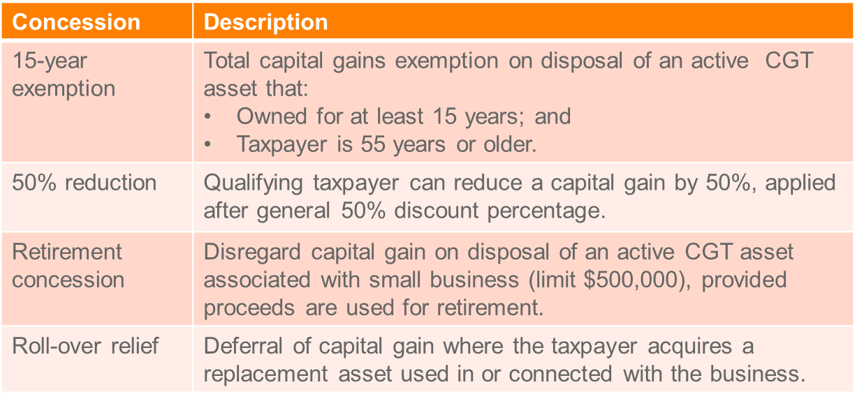

Example re 15 Year Exemption (subdiv 152-B)
Jo is 60 years old. He has owned the local newsagency which he purchased in 1986 for $50,000. Jo decides to retire as he wants to travel the world. In March 2018 Jo sells the business for $250,000, making a capital gain of $200,000.

Assuming Jo meets the three basic conditions to qualify for the small business exemptions, he will qualify for the 15-year exemption as he is over 55 and has owned the business for more than 15 years. As this will exempt all capital gains made from the sale of the business, Jo will not need to consider any other exemptions or concessions, nor will he need to consider indexation.

Example re 50% Reduction (subdiv 152-C)
Zara, who operates a small manufacturing business, disposes of a CGT asset. She owned the CGT asset for three years. It was used as an active asset of the business.

Zara qualifies for the CGT 50% discount and for the small business 50% reduction. From the CGT event she makes a capital gain of $20,000 and she sells another asset, which gives her an additional capital loss of $5,000 in the income year

Zara calculates her net capital gain for the year as follows:
- $20,000 - $5,000 = $15,000
- $15,000- (50% X $15,000) = $7,500
- $7,500- (50% X $7,500) = $3,750
If she chose the rollover or the retirement exemption, some or all of this remaining capital gain would be disregarded.

Example re Retirement Exemption (subdiv 152-D)
Jack acquired a farm in 2011. In December 2017, at the age of 60, he retires and transfers the farm to his son for no consideration. The market value of the farm was $1 million, so the market value substitution rule applies (s 116-30). It deems that the capital proceeds equal the market value of the farm.

The cost base of the farm was $600,000, so, assuming the other retirement exemption conditions are satisfied, Jack made a capital gain of $400,000.

Jack reduces his capital gain twice: first, by the 50% CGT general discount (div 115) to $200,000; then further, by the 50% active asset reduction (, to $100,000. Although he received no capital proceeds, and assuming the other retirement exemption conditions are satisfied, Jack may choose to apply the retirement exemption for the full amount of the remaining $100,000 capital gain.

Example re Rollover Relief (subdiv 152-E)
Jude's small business has an original capital gain of $100,000 on the disposal of an active asset. After Jude applies the CGT general discount and 50% active asset reduction, his original capital gain is reduced to $25,000.

If we assume the first and second elements of the cost base of the business' replacement asset total $20,000, this amount can be disregarded under the roll-over, leaving Jude with a final capital gain of $5,000.

Record Keeping
- What records - s 121-20
- all transactions effecting CGT events
- date acquisition and disposal
- each cost base element
- consideration on disposal
- parties to the transaction
- Retain records for 5 years - s 121-25

Revision questions
Elements to look at in a question involving the disposal of an asset:
Mere realisation of an asset or OI?
1. Isolated transaction – forms a business in itself (Whitford’s Beach)
2. Extraordinary transaction - (Myer Emporium)
Strands of Myer

Question 1
Five years ago Bruce purchases 10 hectares of land for $1 million in an area that was ripe for subdivision. Legal fees and stamp duty in relation to the purchase were $50,000. At the time of purchase he intended to get planning permission from the local council to develop the land by subdivision and then resell it at a proﬁt, but instead he leased it for grazing horses. Three years ago Bruce attempted to get planning permission to subdivide his 10 hectares, but it proved very difficult, and finally in March of the current tax year the local council refused permission to subdivide. Bruce reluctantly sold the land in May for $3 million, incurring legal fees and agents commission of $75,000.

Required: What are the tax consequences of Bruce’s sale?

Isolated transaction that forms a business in itself? No significant development of the land, so the Whitford’s Beach principle does not apple as there has been no activity on the land that forms a business in itself.

Extraordinary transaction? Has there been a commercial transaction? Yes he has bought land with the intention of making a profit. There was a profit making intention when he acquired the asset (sub divide and make a profit). He fact that h

Question 2
Tom Brown is a General Manager in a large international construction firm called Buildfast. Tom's investment portfolio comprises of the following:

Asset | Acquisition Date | Acquisition Price | Notes
Richmond Property | 24 June 2015 | $600,000 | - Property is a vacant warehouse.

Tom loved working with his hands, and had a hobby as a furniture-maker. Tom set up a studio in his backyard so that he could pursue his hobby without bothering his wife.

Tom wanted to move his studio to somewhere bigger so that he could make more furniture. He decided to renovate a vacant warehouse that he owned in Richmond. He bought the property back in 2015 as a friend told him that Richmond was popular and the land would increase in value in the next 10 years. He incurred legal fees and stamp duty of $25,000 in relation to the purchase of the Richmond property. He engaged an architect to help him renovate the warehouse. The architect advised Tom to keep his studio in his backyard and turn the vacant warehouse in Richmond into 15 apartments and sell them. Tom thought this was a good idea. Tom built the apartments using a builder who charged him $1.2million to do the construction. The value of the vacant warehouse at the time the construction commenced was $1.1million. He sold the 15 apartments in January 2018 for $4.7million, incurring legal fees and agents commission of $80,000.

Required: Explain to Tom Brown how the above-mentioned transactions would or would not constitute assessable income under the Income Tax Assessment Acts. Include calculations. Use legislation and case law to support your answer.

Significant development in the property, which resulted in a gain. Makes it an isolated transaction that forms a business in itself and OI under Whitford’s Beach.

Still need to look at Myer- extraordinary transaction. Doesn’t look like it is a gain that is connected to the carrying on of a business. It is a commercial transaction, intention was to make a profit, friend told him it would increase in value. The profit was not realised in the manner intended, so the first strand of Myer does not apply: Westfield.

So gain is OI according to Whitford’s Beach. OI = Sale proceeds – (land value at time development commenced + Development costs)
4.7m - (1.1m+ 1.2m & 80K) = amount assessable under s 6-5

Question 3
Olivia is doctor. Olivia’s investment portfolio comprises of the following:

Asset | Acquisition Date | Acquisition Price | Notes
Painting | 10 September 2000 | $60,000 | - Painting by a well-known Australian artist.
Farmland | 20 March 2012 | $1,500,000 | - Property is 20 ha of vacant farmland in Little River.

When Olivia bought the Farmland (see Olivia’s investment portfolio, above), she knew that the local Council was considering allowing farmland in the Little River area to be used for housing developments. She expected that the housing developments would commence in the next five years pushing up the price of the Farmland considerably. She bought the land with the intention of holding the land and then selling it to a developer within the next five years. She incurred legal fees and stamp duty in relation to the purchase of $10,000.

By October 2016, no significant housing developments had been approved in the area by the local Council. In November 2016, Olivia decided to subdivide the land into two blocks of 10 ha each. The subdivision cost $20,000. The Council approval for the subdivision did not require her to do any work to the land apart from putting in new fences. In February 2017, she sold one block to the farmer next door who wanted to expand his plantings of lettuce and zucchini. The farmer paid her $1,300,000. The other block was near the Werribee Zoo so she decided to build a motel and restaurant which would allow visitors to the Zoo to stay overnight in the local area. The block has a market value of $800,000 at the time the construction commenced. The construction costs totalled $1,000,000. She sold the motel and the restaurant to the Werribee Zoo in August 2017 for $3,000,000. She incurred legal fees and agents commission of $60,000 in relation to the sale.

Olivia decided she needed funds to buy medical equipment, so she sold her Painting (see Olivia’s investment portfolio, above) to her brother for an amount of $120,000 on 1 May 2017. At the time of sale, the Painting was valued at $240,000.

She had capital losses of $20,000 resulting from a loss she made when selling an antique dressing table in 2014.

Required: Explain to Olivia how the above-mentioned transactions would constitute assessable income under the Income Tax Assessment Acts. Use legislation and case law to support your answer.

Land sold to farmer:
OI or a mere realisation from selling an asset?
- Whitford’s Beach: Has an activity happened to the farm that would form a business in itself? – No the facts hint that there was not a sufficient amount of capital planning or effort. Only a subdivision which did not require her to do anything to the land but put in new fences.
  - Reference Casimaty
- Myer First strand: Intention to make a profit? Yes her intention was to make a profit by holding land and then selling it to housing developers. She has abandoned her original intention, any profit realised was not in a manner with regard to her previous intention, thus a capital gain.

Land and building sold to Werribee Zoo:
OI or mere realisation of an asset?
- Whitford’s beach: A sufficient amount of development has happened which arguably forms a business in itself. Hence an isolated business activity and assessable as OI.
- Not a situation where Myer 1 would apply as she has abandoned her original intention: Westfield.

Sale proceeds – (Land value at time of development + Development Costs)
4.7M – (0.8M + 1M + Half subdivision costs (10K) + legal and agents fees of 60K) = $

Paintings:
CGT event A1
Time: May 17
Collectible:

